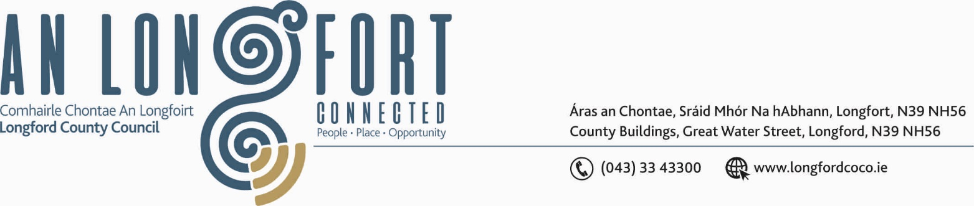

GRANARD MUNICIPAL DISTRICT

Please note venue of Meeting –
Council Chamber, Aras an Chontae, Great Water Street.

7th February 2020.

To: Each Member of Granard Municipal District.

Dear Member,

You are requested to attend Meeting of Granard Municipal District to be held in the Council Chamber, Aras an Chontae, Great Water Street, Longford, on Thursday,
13th February 2020 at 3.30 p.m. to transact business, as set out on the Agenda hereunder.

Yours sincerely,
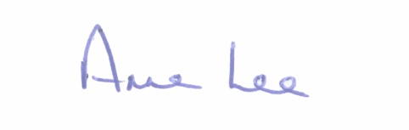

_______________
Anne Lee,
Meetings Administrator.

AGENDA

- To consider and approve Schedule of Granard Municipal District Works - Report enclosed.



